Variety Pack

(8)- 8oz. Rib eye Steak
(8)- 8oz. New York Strip Steak
(8)- 8oz. Top Sirloin Steak
(3)- 2 lb. Chuck Roasts
(8)- 1/4 lb. Sirloin Patties
(8)- 10 oz. Boneless Chicken Breast
(12)- 4 oz. Center Cut Pork Chops

$339.99

Ultimate Deluxe Deal
(6)- 8oz. Angus Rib eye steaks
(6)- 8oz. Angus New York strips
(6)- 8 oz. Filet Mignon
(6)- 8 oz. Boneless Skinless Chicken Breast
(6)- 10 oz. Choice Angus Top Sirloin Steaks
(2)- 2.5 lb. Baby Backs
$259.99!!!

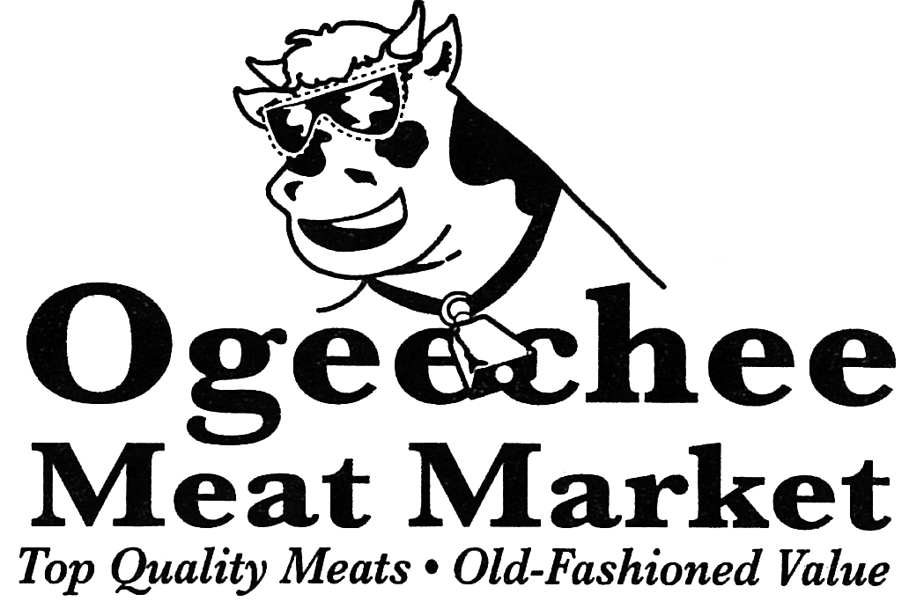

Great steaks to fill the Freezer!!!

